1. What machine you ran this on

OSU Rabbit

1. Show the tables and graphs

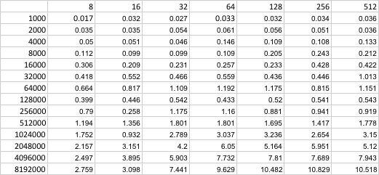

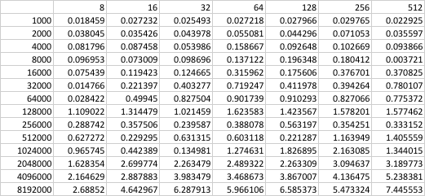

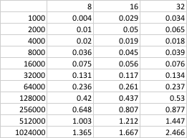

1. What patterns are you seeing in the performance curves?
2. Why do you think the patterns look this way?
3. What is the performance difference between doing a Multiply and doing a Multiply-Add?
4. What does that mean for the proper use of GPU parallel computing?